Maciej Zawodniok, Ph.D.

Associate Professor, Electrical and Computer Engineering (ECE) Department,
Missouri University of Science and Technology
133 Emerson Hall, 301 W. 16th St., Rolla, Missouri 65409 – 0370,
Phone: 573-308-2319, Fax: 573-341-4532, E-mail: mjzx9c@mst.edu,

Table of Contents
Resume/CV 2
Areas Of Interest: Wireless Networks and Communication, Networked Systems and Applications, Cyber-Physical Systems, Embedded Systems and Sensors, Digital Twins 2
Academic and Work Experience 2
Awards 2
Publications 3
Books/Book Chapters 3
Journals Published (Post Tenure: 17 journals, incl. 14 with own students as first authors) 3
Submitted/Under Revisions Journals (2 journals): 5
Conferences (Post Tenure: 27 conference papers, incl. 25 with my students as first authors) 5
Submitted Conference Papers: 9
Patents and Invention Disclosures 9
Technical presentations and Demonstrations 10
Services 12
Advising 14
Graduated Students (Post-Tenure: 8 PhD, 7 MS, 18 UG – many transitioned to Graduate degrees) 14
Current Students (4 PhD, 2 UG) 15
Funded Research (Post Tenure, 2014-Present) 16
Teaching 18
Overall Teaching Effectiveness Evaluation: 3.8 (Spring 2025) 18

Resume/CV

Areas Of Interest: Wireless Networks and Communication, Networked Systems and Applications, Cyber-Physical Systems, Embedded Systems and Sensors, Digital Twins

Academic and Work Experience

Academic Experience
- PhD. in Computer Engineering, University of Missouri-Rolla May 2006
Dissertation topic “Distributed Power Control (DPC)-based Energy Efficient Protocols for Wireless
Networks” (defended December 22nd, 2005), Advisor: Prof. Jagannathan Sarangapani
- M.S. in Computer Science, Politechnika Śląska w Gliwicach (Poland), Nov. 1999
Specialization: "Databases, Computer Networks and Systems", Advisor: Prof. Adam Mrozek

Work Experience
• | Missouri S&T  Associate Professor (Tenured), Electrical and Computer Engineering,  Assistant Site Director, NSF Industry/University Cooperative Research Center (I/UCRC) on Intelligent Maintenance Systems (2008-2017) | 08/2014-Present
• | Missouri S&T  Assistant Professor, Electrical and Computer Engineering | 08/2008-07/2014
• | University of Missouri–Rolla  Post-Doctoral Fellow, Electrical and Computer Engineering | 01/2006-08/2008
• | University of Missouri–Rolla  GRA, Electrical and Computer engineering | 07/2003-12/2005
• | Motorola Polska Sp. z o.o.(Kraków, Poland),  Software Engineer | 12/2002–06/2003
• | Leliwa Sp. z o.o. (Kraków, Poland)  Senior Training Specialist | 02/2001–11/2002
• | Leliwa Sp. z o.o. (Kraków, Poland)  Training Specialist | 05/2000–01/2001

Awards
- Best Paper Award – for paper on “RFID Solution for Tracking Components Life for Rotor Head Assembly” at 2019 VFS Forum 75.
- Best Paper Award – for paper on “Ubiquitous Tracking Using Motion and Location Sensor with Application to Smartphone" at IEEE SMARTCOMP 2017.
- Best Paper Nomination – for paper on "Application of low scattering antennas to RFID networks” at 2016 IEEE International Conference on RFID (RFID).
- 2013 Outstanding Branch Counselor, IEEE St Louis Section
- 2013 Outstanding Branch Counselor, IEEE Region 5
- Outstanding Teaching Commendation Award, the School of Extended Learning
- 2012 Outstanding New Advisor of the Year Award
- Global Learning 2012 Outstanding Teaching Award of Excellence

Publications
*My graduate students as first author

Books/Book Chapters

- Maciej J. Zawodniok and *Sambhav Kundaikar, “Optimized Built-In Self-Test Technique for CAEN-Based Nanofabric Systems,” pp. 569-590, chapter 45 in Nanoelectronic Device Applications Handbook, James E. Morris & Krzysztof Iniewski (editors), CRC Press (Taylor & Francis Group), June 17, 2013. (share:100%)
- *Behdis Eslamnour, S. Jagannathan, and Maciej Zawodniok, “Cooperative Resource Allocation for Primary and Secondary Users with Adjustable Priorities in Cognitive Radio Networks,” pp. 438-448, chapter in Advances in Digital Image Processing and Information Technology, Dhinaharan Nagamalai, Eric Renault, and Murugan Dhanuskodi (editors), Vol. 205, Springer Berlin Heidelberg, 2011. (share:50%)

Journals Published (Post Tenure: 17 journals, incl. 14 with own students as first authors)

- *M. Omanda Bouraima, *S. Thompson and M. J. Zawodniok, "Enhancing Measurement Accuracy: The Impact of Missing Data on Parameter Estimation in Mass–Spring–Damper Systems," in IEEE Transactions on Instrumentation and Measurement, vol. 75, pp. 1-12, 2026, Art no. 1002412, doi: 10.1109/TIM.2026.3676091. (share:100%)
- *S. J. Patel and M. J. Zawodniok, "3D Localization of RFID Antenna Tags Using Convolutional Neural Networks," in IEEE Transactions on Instrumentation and Measurement, vol. 71, pp. 1-11, 2022, Art no. 8001311, doi: 10.1109/TIM.2022.3146604. (share:100%)
- *N. D. Price, M. J. Zawodniok and I. G. Guardiola, "Transceivers as a Resource: Scheduling Time and Bandwidth in Software-Defined Radio," in IEEE Access, vol. 8, pp. 132603-132613, 2020, doi: 10.1109/ACCESS.2020.3011051. (share:75%)
- *A. M. M. Chandran, *L. Wang and M. Zawodniok, "Channel Estimators for Full-Duplex Communication Using Orthogonal Pilot Sequences," in IEEE Access, vol. 8, pp. 117706-117713, 2020, doi: 10.1109/ACCESS.2020.3002726. (share:75%)
- *L. Wang, L. Feng, and M. Zawodniok, “ARPAP: A Novel Antenna-Radiation-Pattern-Aware Power-Based Positioning in RF System,” IEEE Transactions on Mobile Computing, pp. 1–1, 2019, doi: 10.1109/TMC.2019.2959983. (share:75%)
- *S. Bi, T. Wang, *L. Wang, and M. Zawodniok, “Novel cyber fault prognosis and resilience control for cyber–physical systems,” IET Cyber-Physical Systems: Theory & Applications, Feb. 2019, doi:
10.1049/iet-cps.2018.5061. (share:100%)
- *L. Wang and M. Zawodniok, “New Theoretical Limit Analysis of LoS and RSS Based Positioning Methods for Ricean Fading Channel in RF Systems,” IEEE Transactions on Mobile Computing, pp. 1–1, 2019. (share:100%)
- *S. Ebrahimi-Asl, M. T. A. Ghasr, and M. Zawodniok, “Cooperative Interference Control in Neighboring Passive Scattering Antennas,” IEEE Journal of Radio Frequency Identification, vol. 2, no. 3, pp. 152–158, Sep. 2018. (share:75%)
- M. G. Fikru, G. Gelles, A.-M. Ichim, J. W. Kimball, J. D. Smith, and M. J. Zawodniok, “An economic model for residential energy consumption, generation, storage and reliance on cleaner energy,” Renewable Energy, vol. 119, pp. 429–438, Apr. 2018. (share:10%)
- *S. Ebrahimi-Asl, M. T. Ghasr, and M. J. Zawodniok, “Design of Dual-Loaded RFID Tag for Higher Order Modulations,” IEEE Transactions on Microwave Theory and Techniques, vol. 66, no. 1, pp. 410–419, Jan. 2018. (share:75%)
- *S. Ebrahimi-Asl, M. T. A. Ghasr, and M. J. Zawodniok, “A Solution to Low Read Rate Problem in RFID Scattering Networks,” IEEE Journal of Radio Frequency Identification, vol. 1, no. 2, pp. 176– 184, Jun. 2017. (share:75%)
- *S. Bi and M. Zawodniok, “PDF-based tuning of stochastic optimal controller design for cyberphysical systems with uncertain delay dynamics,” IET Cyber-Physical Systems: Theory Applications, vol. 2, no. 1, pp. 1–9, 2017. (share:100%)
- *L. Wang and M. J. Zawodniok, "Bias and CRB Analysis of LoS-Based and RSS-Based Ranging Methods," in IEEE Transactions on Vehicular Technology, vol. 65, no. 11, pp. 9085-9097, Nov. 2016. doi: 10.1109/TVT.2016.2518166 (share:100%)
- *Thotla, V.; Zawodniok, M., "Detection of Multiple R/C Devices Using MVDR and Genetic Algorithms," in Instrumentation and Measurement, IEEE Transactions on , vol.64, no.10, pp.2821-2828, Oct. 2015; doi: 10.1109/TIM.2015.2415112 (share:100%)
- *Thotla, V.; Zawodniok, M.J.; Jagannathan, S.; Ghasr, M.T.A.; Agarwal, S., "Detection and Localization of Multiple R/C Electronic Devices Using Array Detectors," in Instrumentation and Measurement, IEEE Transactions on , vol.64, no.1, pp.241-251, Jan. 2015; doi: 10.1109/TIM.2014.2331432 (share:25%)
- Paul, T.; Kimball, J.W.; Zawodniok, M.; Roth, T.P.; McMillin, B.; Chellappan, S., "Unified Invariants for Cyber-Physical Switched System Stability," Smart Grid, IEEE Transactions on , vol.5, no.1, pp.112,120, Jan. 2014. (share:30%)
- Ferdowsi, H.; Jagannathan, S.; Zawodniok, M., "An Online Outlier Identification and Removal Scheme for Improving Fault Detection Performance," Neural Networks and Learning Systems, IEEE Transactions on , vol.25, no.5, pp.908,919, May 2014. (share:50%)

Journal Papers (Tenure Track: 17 Journals)
- *Thotla, V.; Ghasr, M.T.A.; Zawodniok, M.J.; Jagannathan, S.; Agarwal, S., "Detection of Super-Regenerative Receivers Using Hurst Parameter," Instrumentation and Measurement, IEEE Transactions on , vol.62, no.11, pp.3006,3014, Nov. 2013. (share:30%)
- M. Tayeb Ghasr, V. Thotla, M. Zawodniok, and S. Jagannathan, “Detection of Super Regenerative Receiver using Amplitude Modulated Stimulation,” Instrumentation and Measurement, IEEE Transactions on, Vol. 62 , No. 7, pp. 2029 – 2036, 12 April 2013. (share:30%)
- *Sandeep Kolli and M. Zawodniok, “A Dynamic Programming Approach: Improving Performance of the Wireless Networks,” Journal of Parallel and Distributed Computing (JPDC) , vol. 71, no. 11, pp. 1447-1459, 2011. (share:100%)
- *B. Eslamnour, J. Sarangapani, and M. Zawodniok “Dynamic Channel Allocation in Wireless Networks Using Adaptive Learning Automata,” International Journal of Wireless
Information Networks, Springer Netherlands, pp. 1-14, 20 May 2011. (share:40%)
- J.W. Kimball, M. Zawodniok, "Reducing Common-Mode Voltage in Three-Phase SineTriangle PWM with Interleaved Carriers," Power Electronics, IEEE Transactions on, Vol. 26 , No. 8, pp. 2229-2236, 15 November 2010. (share:40%)
- J. W. Fonda, M. Zawodniok, S. Jagannathan, and S. E. Watkins, Adaptive Distributed Fair Scheduling for Multiple Channels in Wireless Sensor Networks, International Journal of Distributed Sensor Networks, Vol. 5, No. 6, pp. 824-833, November 2009. (share:30%)
- A. Soylemezoglu, M. Zawodniok, S. Jagannathan, "RFID-based Smart Freezer," IEEE Transactions on Industrial Electronics, vol.56, no.7, pp.2347-2356, July 2009 (share:40%)
- T. Landstra, S. Jagannathan and M. Zawodniok, Energy-Efficient Hybrid Key Management Protocol for Wireless Sensor Networks, International Journal of Network Security, Vol.9, No.2, pp.121-134, 2009. (share:25%)
- Fonda, James W., Steve E. Watkins, S. Jagannathan, and Maciej Zawodniok. "Embeddable Sensor Mote for Structural Monitoring” Proc. SPIE, Vol. 6932, 69322V (2008). (share:20%)
- J. W. Fonda, M. Zawodniok, S. Jagannathan, and S. E. Watkins, OEDSR: Optimized EnergyDelay Sub-Network Routing Protocol Development and Implementation for Wireless Sensor Networks, Journal of Smart Materials and Structures, Vol. 17, pp. 1-14, June 2008. (share:30%)
- M. Zawodniok and S. Jagannathan, Predictive Congestion Control MAC Protocol for Wireless Sensor Networks, IEEE Transactions on Wireless Communications, Vol. 6, No. 11, pp. 3955–3963, November 2007.
- M. Zawodniok and S. Jagannathan, Energy-Efficient Rate Adaptation MAC Protocol for Wireless Ad Hoc Networks, International Journal of Wireless Information Networks (IJWI), Vol. 14, No 4, pp. 251-263, November 2007.
- S. Jagannathan, M. Zawodniok and Q. Shang, Distributed power control of cellular networks in the presence of channel uncertainties, IEEE Transactions on Wireless Communication, Vol. 5, No. 3, pp.540-549, March 2006.
- A. Soylemezoglu, M. Zawodniok, K. Cha, D. Hall, J. Birt, C. Saygin, & S. Jagannathan, A Testbed Architecture for Auto-ID Technologies, Assembly Automation Journal; vol.26, no.2, p.127-136, 2006.
- K. Cha, M. Zawodniok, A. Ramachandran, J. Sarangapani, and C. Saygin, Interference Mitigation and Read-Rate Improvement in RFID-based Network-Centric Environments, Journal of Sensor Review, vol. 26, issue 4, pp. 318-325, 2006.

Submitted/Under Revisions Journals (2 journals):

- *P. Podder, M. Zawodniok, and S. Madria, “Dense UAVNet: Densely Connected Convolutional Networks for RF-Based UAV Type Identification,” submitted to IEEE Transactions on Artificial Intelligence. (share:50%)
- *Michtath O. Bouraima, Maciej Zawodniok, “CRLB-Based Analysis of Joint Phase and Frequency Estimation with Missing and Quantized Sensor Data”, submitted to IEEE Sensors Letter. (share:100%)

Conferences (Post Tenure: 27 conference papers, incl. 25 with my students as first authors)

- *P. Podder, M. Zawodniok, and S. Madria, “WaveSpec-DeiT: A Wavelet-Inspired Spectral Transformer for RF-Based UAV Identification,” in 2026 27th IEEE International Conference on Mobile Data Management (MDM), Jun. 2026.
- *P. Podder, M. Zawodniok and S. Madria, "Multi-Scale Filter Bank with Feature Dimensionality Reduction for RF-Based UAV Identification,” in 2026 11th International Conference on Smart and Sustainable Technologies (SpliTech), Jun. 2026.
- *M. O. Bouraima, and M. Zawodniok, “Phase-Guided Bayesian Model-Based Imputation for Missing Sensor Data in Mass-Spring-Damper Systems,” in 2026 IEEE International Instrumentation and Measurement Technology Conference (I2MTC), May 2026.
- *S. P. Koneru, M. Zawodniok, T. Schulze, and D. Myers, “Timing Variability of Ring Oscillators in FPGAs,” in 2026 IEEE International Instrumentation and Measurement Technology Conference (I2MTC), May 2026.
- *P. Podder, M. A. Rahman, M. Zawodniok and S. Madria, "RF-AttenNet: A Hybrid Attention-Enhanced Network for Mixed Signal Classification in UAV Swarm Detection," 2026 18th International Conference on COMmunication Systems and NETworks (COMSNETS), Bengaluru, India, 2026, pp. 482-490, doi: 10.1109/COMSNETS67989.2026.11418162.
- *P. Podder, M. Zawodniok, and S. Madria, “Deep Learning for UAV Classification: Impact of Noise and Multipath Fading in RF Signals,” in 2025 10th International Conference on Smart and Sustainable Technologies (SpliTech), Jun. 2025, pp. 1–6. doi: 10.23919/SpliTech65624.2025.11091682.
- *Anhar Sami Mohammed, *Prajoy Podder, Maciej Zawodniok, “Advancements in Wireless-Enabled Wearable Biosensors for Real-Time Fatigue Monitoring: A Review,” to appear in DoSCI 2025.
- *S. Thompson and M. Zawodniok, “An Entropy-Bounded, General, Model-Based Framework for Lossy Compression of Sensor Data,” in 2025 IEEE International Instrumentation and Measurement Technology Conference (I2MTC), May 2025, pp. 1–6. doi: 10.1109/I2MTC62753.2025.11079003.
- *S. Thompson, *M. O. Bouraima, and M. Zawodniok, “Enhancing Measurement Accuracy in Industrial Applications: The Impact of Sensor Data Imputation on Model Parameter Estimation,” in 2025 IEEE International Instrumentation and Measurement Technology Conference (I2MTC), May 2025, pp. 1–6. doi: 10.1109/I2MTC62753.2025.11078961.
- *A. S. Mohammed, *P. Podder, M. Zawodniok, and C. Dagli, “Cognitive Fatigue Detection Using Photoplethysmography (PPG) and Reaction Time Data,” in 2025 8th International Conference on Information and Computer Technologies (ICICT), Mar. 2025, pp. 435–441. doi: 10.1109/ICICT64582.2025.00074.
- *P. Podder and M. Zawodniok, “Survey and Analysis of Communication and Routing Mechanisms for UAVs in Wireless Sensor Networks,” in Proceedings of Fourth International Conference on Computing and Communication Networks, A. Kumar, A. Swaroop, and P. Shukla, Eds., Singapore: Springer Nature, 2025, pp. 333–348. doi: 10.1007/978-981-96-3250-3_27.
- *P. Podder, M. Zawodniok, and S. Madria, “Deep Learning for UAV Detection and Classification via Radio Frequency Signal Analysis,” in 2024 25th IEEE International Conference on Mobile Data Management (MDM), Jun. 2024, pp. 165–174. doi: 10.1109/MDM61037.2024.00040.
- *J. Morrow, M. Zawodniok, and *A. S. Mohammed, “Impact of AI on the HRI Dynamic in Search and Rescue Operations using UAV Swarms,” in 2024 IEEE International Symposium on Robotic and Sensors Environments (ROSE), Jun. 2024, pp. 01–08. doi: 10.1109/ROSE62198.2024.10590796.
- L. A. Smith, V. Kumar Tanwar, M. Zawodniok and S. Madria, "RaFID: A Lightweight Approach to Radio Frequency Interference Detection in Time Domain using LSTM and Statistical Analysis," 2023 24th IEEE International Conference on Mobile Data Management (MDM), Singapore, Singapore, 2023, pp. 209-214, doi: 10.1109/MDM58254.2023.00043.
- *S. J. Patel and M. Zawodniok, “DNN-Based RFID Antenna Tags Localization,” in 2021 IEEE International Instrumentation and Measurement Technology Conference (I2MTC), May 2021, pp. 1–6. doi: 10.1109/I2MTC50364.2021.9460004.
- *A. M. Maran Chandran, M. Zawodniok and A. Phillips, "Convergence Communication over Heterogeneous Mesh Network for Disaster and Underserved Areas," 2020 IEEE 17th Annual Consumer Communications & Networking Conference (CCNC), 2020, pp. 1-4, doi:
10.1109/CCNC46108.2020.9045227.
- *S. Patel M. Zawodniok and J. Benesty "Dcase 2020 task 3: A single stage fully convolutional neural network for sound source localization and detection" DCASE2020 Challenge July 2020.
- *S. J. Patel and M. Zawodniok, "DNN-Based RFID Antenna Tags Localization," 2021 IEEE
International Instrumentation and Measurement Technology Conference (I2MTC), 2021, pp. 1-6, doi:
10.1109/I2MTC50364.2021.9460004.
- *A. M. M. Chandran, M. Zawodniok and A. Adekpedjou, "Targeted Learning for the Dynamic
Selection of Channel Estimation Methodology," 2020 IEEE International Conference on Smart
Computing (SMARTCOMP), 2020, pp. 250-252, doi: 10.1109/SMARTCOMP50058.2020.00055.
- *A. M. Maran Chandran and M. Zawodniok, "Measurement of Internal Self-Interference of USRP family of devices in Full-Duplex Operations," 2020 IEEE International Instrumentation and Measurement Technology Conference (I2MTC), Dubrovnik, Croatia, 2020, pp. 1-6, doi:
10.1109/I2MTC43012.2020.9129319.
- *A. M. Maran Chandran, M. Zawodniok, and A. Phillips, “Convergence Communication over Heterogeneous Mesh Network for Disaster and Underserved Areas,” in 2020 IEEE 17th Annual Consumer Communications Networking Conference (CCNC), Jan. 2020, pp. 1–4, doi:
10.1109/CCNC46108.2020.9045227.
- *S. J. Patel and M. Zawodniok, “Passive RFID tags for Metallic Environments Using Phased Array Reader Antennas,” in 2019 IEEE International Instrumentation and Measurement Technology Conference (I2MTC), May 2019, pp. 1–6, doi: 10.1109/I2MTC.2019.8827142.
- M. Zawodniok, *S. Patel, Nagaraja Iyyer, Nam D. Phan, Kishan Goel, “RFID Solution for Tracking Components Life for Rotor Head Assembly,” 2019 VFS Forum 75, May 2019. Best Paper Award.
- *S. J. Patel, S. L. Grant, M. Zawodniok, and J. Benesty, “On the Design of Optimal Linear Microphone Array Geometries,” in 2018 16th International Workshop on Acoustic Signal Enhancement (IWAENC), 2018, pp. 501–505.
- *L. Wang, L. Feng, and M. Zawodniok, “Ubiquitous Tracking Using Motion and Location Sensor with Application to Smartphone,” in 2017 IEEE International Conference on Smart Computing (SMARTCOMP), 2017, pp. 1–8. Best Paper Award.
- *S. Ebrahimi-Asl, M. T. A. Ghasr and M. Zawodniok, "Application of low scattering antennas to RFID networks," 2016 IEEE International Conference on RFID (RFID), Orlando, FL, 2016, pp. 1-7. doi: 10.1109/RFID.2016.7488008. Best Paper Nomination.
- *A.M.M. Chandran and M. Zawodniok, “Transmitter Leakage Analysis When Operating USRP (N210) in Duplex Mode” to appear in Proc. Of IEEE I2MTC 2015, May 2015.

Conferences (Tenure Track: 34 conference papers)
- *S. Ebrahimi Asl, M. Behgam, M. Zawodniok, and M.T. Ghasr, “Experimental Validation of Minimum Variance Unbiased Estimator of Structural Scattering Coefficient for an RFID antenna Using Linear Model,” Proc. of IEEE I2MTC 2014, pp. 1-1, May 2014
- *A. Saxena and M. Zawodniok, “Indoor Positioning System Using Geo-Magnetic Field,” Proc. of IEEE I2MTC 2014, pp. , May 2014
- *Thotla, V.; Zawodniok, M., "Hurst parameter based detection of multiple super regenerative receivers using MVDR," in Instrumentation and Measurement Technology Conference (I2MTC) Proceedings, 2014 IEEE International, pp.567-571, 12-15 May 2014; doi: 10.1109/I2MTC.2014.6860808
- A. Choudhari, H. Ramaprasad, S. Chellappan, B. McMillin, J. Kimball, and M. Zawodniok, “Adaptive Scheduling with Explicit Congestion Notification in a Cyber-Physical Smart Grid System,” presented at the Software Engineering and Advanced Applications (SEAA), 2014 40th EUROMICRO Conference on, 2014, pp. 309–317.
- Choudhari, A.; Ramaprasad, H.; Paul, T.; Kimball, J.W.; Zawodniok, M.; McMillin, B.; Chellappan, S., "Stability of a Cyber-physical Smart Grid System Using Cooperating Invariants," Computer Software and Applications Conference (COMPSAC), 2013 IEEE 37th Annual , vol., no., pp.760,769, 22-26 July 2013.
- *Asl, S.E.; Ghasr, M.T.; Zawodniok, M.; Robinson, K.E., "Preliminary study of mutual coupling effect on a passive RFID antenna array," Instrumentation and Measurement Technology Conference (I2MTC), 2013 IEEE International, pp.138,141, 6-9 May 2013
- *Padaki, A.V.; Zawodniok, M., "TDMA for wireless passive backscatter networks: An information theoretic approach," Local Computer Networks (LCN), 2012 IEEE 37th Conference on , pp.264-267, 22-25 Oct. 2012 (doi: 10.1109/LCN.2012.6423624)
- *Wang, L.; Zawodniok, M., "RSSI-based localization in cellular networks," Local Computer Networks Workshops (LCN Workshops), 2012 IEEE 37th Conference on, pp.820-826, 22-25 Oct. 2012. (doi: 10.1109/LCNW.2012.6424069)
- R.S. Kraleti, M. Zawodniok, S. Jagannathan, "Model based diagnostics and prognostics of three-phase induction motor for vapor compressor applications," Prognostics and Health Management (PHM), 2012 IEEE Conference on, pp.1-7, 18-21 June 2012. doi: 10.1109/ICPHM.2012.6299525
- *V. Thotla, M. T. A. Ghasr, M. Zawodniok, S. Jagannathan, and S. Agarwal, “Detection and localization of R/C electronic devices using Hurst parameter,” Proc. SPIE 8359, Sensors, and Command, Control, Communications, and Intelligence (C3I) Technologies for Homeland Security and Homeland Defense XI, 835915 (May 1, 2012); doi:10.1117/12.919375.
- *Thotla, V.; Ghasr, M.T.A.; Zawodniok, M.; Jagannathan, S.; Agarwal, S.; , "Detection and localization of multiple R/C electronic devices using array detectors," Instrumentation and
Measurement Technology Conference (I2MTC), 2012 IEEE International, pp.1687-1691, 1316 May 2012. doi: 10.1109/I2MTC.2012.6229345
- Paul, T.; Kimball, J.W.; Zawodniok, M.; Roth, T.P.; McMillin, B.; , "Invariants as a unified knowledge model for Cyber-Physical Systems," Service-Oriented Computing and Applications (SOCA), 2011 IEEE International Conference on , pp.1-8, 12-14 Dec. 2011
- *S. Kundaikar and M. Zawodniok, “Optimized Built-In Self-Test Technique for CAEN-Based Nanofabric Systems,” Nanotechnology (IEEE-NANO), 2011 11th IEEE Conference on, pp.1717-1722, 15-18 Aug. 2011.
- E. Taqieddin, M. Zawodniok, Jagannathan S., and A. Miller, “Hardware Implementation of the Energy-efficient Hybrid Key Management Protocol for Wireless Sensor Networks,” Accepted to 2011 International Conference on Wireless Networks (ICWN’11).
- *A. Padaki and M. Zawodniok, “Theoretical Capacity Analysis of Multi-hop Backscatter Communication Networks,” Computer Communications and Networks (ICCCN), 2011 Proceedings of 20th International Conference on , pp.1-6, July 31 2011-Aug. 4 2011. doi: 10.1109/ICCCN.2011.6005804
- *Liuju Wu and M. Zawodniok, “Cooperative Approaches Indicating to Capacity and Power Control for Ad Hoc Wireless Network,” Computer Communications and Networks (ICCCN), 2011 Proceedings of 20th International Conference on , pp.1-6, July 31 2011-Aug. 4 2011. doi: 10.1109/ICCCN.2011.6005792
- *S. Roy, L. Wu, and M. Zawodniok, “Spectrum Management for Wireless Networks Using Adaptive Control and Game Theory,” Wireless Communications and Networking Conference
(WCNC), 2011 IEEE, pp.1062-1067, 28-31 March 2011. doi: 10.1109/WCNC.2011.5779307
- *V.R. Surendra and M. Zawodniok, “Multi-hop Framework for Battery-less Devices Using Passive RF Communication,” Wireless Communications and Networking Conference
(WCNC), 2011 IEEE, pp.1149-1154, 28-31 March 2011. doi: 10.1109/WCNC.2011.5779293
- *V.R. Surendra and M. Zawodniok, "Distributed Beamforming Using a Scattering Network," Communication Networks and Services Research Conference (CNSR), 2010 Eighth Annual, pp.116-123, 11-14 May 2010.
- J.W. Kimball and M. Zawodniok, “Reducing common-mode voltage in three-phase sinetriangle PWM with interleaved carriers,” Applied Power Electronics Conference and Exposition (APEC), 2010 Twenty-Fifth Annual IEEE , pp.1508-1513, 21-25 Feb. 2010.
- *S. Kolli and M. Zawodniok, "Energy-efficient multi-key security scheme for wireless sensor network," Local Computer Networks, 2009. LCN 2009. IEEE 34th Conference on, pp.937944, 20-23 Oct. 2009.
- *R. Anguswamy, M. Zawodniok, and S. Jagannathan, ”A Multi-Interface Multi-Channel Routing (MMCR) Protocol for Wireless Ad Hoc Networks,” Wireless Communications and Networking Conference, 2009. WCNC 2009. IEEE , pp.1-6, 5-8 April 2009.
- *B. Elsamnour, M. Zawodniok, and S. Jaganathan, "Dynamic Channel Allocation in Wireless Networks using Adaptive Learning Automata," Wireless Communications and Networking Conference, 2009. WCNC 2009. IEEE , pp.1-6, 5-8 April 2009.
- T. Landstra, M. Zawodniok, and S. Jagannathan, Energy-Efficient Hybrid Key Management Protocol for Wireless Sensor Networks, 32nd IEEE Conf. on Local Computer Networks LCN 2007, pp. 1009-1016, Oct. 2007.
- K.C. Emani, K. Kam, M. Zawodniok, Y.R. Zheng, J. Sarangapani, Improvement of CAN BUS Performance by Using Error-Correction Codes, Proc. Of IEEE Region 5 Technical Conference 2007, pp. 205-210, April 2007.
- F. Ren, Y.R. Zheng, M. Zawodniok, J. Sarangapani, Effects of Electromagnetic Interference on Control Area Network Performance, Proc. Of IEEE Region 5 Technical Conference 2007, pp. 199–204, April 2007.
- M. Zawodniok and S. Jagannathan, Dynamic Programming based Energy-Efficient Rate Adaptation for Wireless Ad Hoc Networks, Proc. of the 31st IEEE Conference on Local Computer Networks (LCN) 2006, pp. 521–524, November 2006.
- J.W. Fonda, M. Zawodniok, S. Jagannathan, S.E. Watkins, Adaptive Distributed Fair Scheduling and Its Implementation in Wireless Sensor Networks, Proc. of IEEE International Conference on Systems, Man and Cybernetics (ICSMC) 2006 in Taiwan, Vol. 4, pp. 3382– 3387, October 2006.
- J.W. Fonda, M. Zawodniok and S. Jagannathan, and S.E. Watkins, Development and Implementation of Optimized Energy-Delay Sub-network Routing Protocol for Wireless Sensor Networks, Proceedings to IEEE CCA/CACSD/ISIC 2006, pp. 119–124, Oct 2006.
- M. Zawodniok and S. Jagannathan, Congestion Control and Routing Schemes for Wireless Sensor Networks, to appear in Proceedings to Forty-Fourth Annual Allerton Conference on Communication, Control, and Computing, 2006.
- M. Zawodniok and S. Jagannathan, Predictive Congestion Control MAC Protocol for Wireless Sensor Networks, IEEE International Conference on Control and Automation (ICCA'05), vol. 1, pp.185-190, June 2005.
- M. Zawodniok and S. Jagannathan, Energy-Efficient Rate Adaptation MAC Protocol for Wireless Ad Hoc Networks, IEEE IPCCC'05, pp.389-394, April 2005.
- S. Jagannathan, M. Zawodniok and Q. Shang, Distributed power control of cellular networks in the presence of channel uncertainties, IEEE INFOCOM, Vol.2, pp. 1055-1066, March 2004.
- M. Zawodniok and S. Jagannathan, A Distributed Power Control MAC Protocol for Wireless Ad Hoc Networks, IEEE WCNC'04, Vol. 3, pp. 1915-1920, March 2004.

Submitted Conference Papers:

Patents and Invention Disclosures

Patents awarded:
- *S. Ebrahimi-Asl, M. T. A. Ghasr, and M. J. Zawodniok, “Design of dual loaded rfid tag for higher order modulations,” US20170098882A1, Apr. 06, 2017 Accessed: Nov. 18, 2024. [Online]. Available: https://patents.google.com/patent/US20170098882A1/en
- J. Sarangapani, M. J. Zawodniok, *V. Thotla, M. T. Ghasr, and J. Hertenstein, “Electronic receiver device detection system and method,” US9689964B2, Jun. 27, 2017 Accessed: Nov. 18, 2024. [Online]. Available: https://patents.google.com/patent/US9689964B2/en
- M. Zawodniok, I. G. Guardiola, D. Bateman, A. Phillips, *A. M. Maran, and *N. D. Price, “Multi-path wireless mesh networks,” US11375430B2, Jun. 28, 2022 Accessed: Nov. 18, 2024. [Online]. Available: https://patents.google.com/patent/US11375430B2/en
- M. Zawodniok, I. G. Guardiola, D. Bateman, A. Phillips, *A. M. Maran, and *N. Price, “Multi-path wireless mesh networks in oil and gas fields,” US9107137B1, Aug. 11, 2015 Accessed: Nov. 18, 2024. [Online]. Available: https://patents.google.com/patent/US9107137B1/en

Invention Disclosures Filed:
- UM Disclosure No. 15MST042, entitled “Implementation Of Invisible Antenna With Application Of RFID Systems”, US Patent Application Serial No. 62/248,870; Filing Date: October 30, 2015; Inventor(s): Shadi Ebrahimi Asl, Maciej Zawodniok and Mohammad Tayeb Ghasr
- UM Disclosure No. 16MST007/8, entitled “Methods and Devices for Improving Performance of RFID System”, US Patent Application Serial No. 62/236,490. Filing Date: 10/02/15; Inventors: Shadi Ebrahimi Asl, Maciej Zawodniok and Mohammad Tayeb Ghasr.
- “Smart Freezer,” Jag Sarangapani, Can Saygin, Maheswaran Thiagarajan, Maciej Zawodniok – University of Missouri Invention Disclosure Number: 07UMR074 (2007).
- “Adaptive Distributed Fair Scheduling Protocol for Wireless Sensor Networks,” Jag Sarangapani, Niranjan Regatte, Maciej Zawodniok – University of Missouri Invention Disclosure Number: 06UMR095 (2006).
- “Multi-hop Routing Protocol for Wireless Ad Hoc and Sensor Networks,” Jag Sarangapani, Sibila Ratnaraj, James Fonda, Maciej Zawodniok – University of Missouri Invention Disclosure Number: 06UMR094 (2006).

Technical presentations and Demonstrations

- Maciej Zawodniok and *Steven Thompson, “Digital Twin Playground for Additive Manufacturing Applications,” Invited presentation at 2024 International Conference on Additive Manufacturing (ICAM 2024), Oct 28 - Nov 1, 2024.
- *S. P. Koneru and M. Zawodniok, “Demo: Framework for Rapidly Reproducible Wireless Mesh Network Testbeds,” in 2024 IEEE 49th Conference on Local Computer Networks (LCN), Oct. 2024, pp. 1–4. doi: 10.1109/LCN60385.2024.10639731.
- Maciej Zawodniok, “Passive RFID Sensing for Rotor-head Maintenance - WISP platform” presented at the IEEE WiSEE 2015, Orlando, FL, December 14-16, 2015.
- Maciej Zawodniok, Jagannathan Sarangpani, Nagaraja Iyyer, Douglas Algera, Amit Singh, and Nam Phan, “Improving Passive RFID Tag Performance: Application to Rotorcraft Dynamic Component Tracking,” Presented at the 15th Australian International Aerospace Congress, 2013.
- *B. Eslamnour, S. Jagannathan, and M. Zawodniok, “Cooperative Resource Allocation for Primary and Secondary Users with Adjustable Priorities in Cognitive Radio Networks,” 3rd International Conference on Wireless & Mobile Networks, (WiMoN-2011).
- P. Kasirajan, H. Xu, M. J. Zawodniok, and S. Jagannathan, “Demonstration of a MultiInterface Multi-Channel Routing Protocol (MMCR) for WSNs using Missouri S&T Motes,” IEEE LCN 2010, Demonstration session, October 2010.
- JJ. W. Fonda, M. J. Zawodniok, S. Jagannathan, A. Salour, D. Miller Jr., “Missouri S&T Mote-Based Demonstration of Energy Monitoring Solution for Network Enabled Manufacturing Using Wireless Sensor Networks (WSN),” IPSN 2008, pp. 559-560, 2008.
- J.W. Fonda, M.J. Zawodniok, J.T. Birt, S. Jagannathan, UMR Mote-based Demonstration of Wireless Sensor Networking Protocols using Pneumatic Testbed, 6th International Symposium on Information Processing in Sensor Networks, IPSN 2007, pp. 569–570, April 2007.
- S. Jagannathan, J.W. Fonda, M. Zawodniok, J. Brit, S.Watkins, Wireless Sensor Network-Based Monitoring and Prognostics for Aerospace Structures, ASM AeroMat 2005, June 2005.
- C. Saygin, K. Cha, A. Soylemezoglu, J. Brit, M. Zawodniok, J. Fonda, E. Taqieddin, M.D. Mills Harris, J. Saragapani, D. Trimble and T. Siegel, A Testbed for Validation and Benchmarking of Auto-ID Solution, ASM AeroMat 2005, June 2005.
- J.W. Fonda, R. Anguswamy, M. Zawodniok, J. Birt, Jagannathan Sarangapani, and C. Saygin, Pull-Type Tool Health Monitoring and Product Quality Verification using Wireless Sensor Networks, ISHM’06, Cincinnati, August 2006
- J. W. Fonda, M. J. Zawodniok, S. Jagannathan, and Can Saygin, “Industrial Monitoring and Control using Wireless Multi-hop Network Routing Protocol”, National Science Foundation Intelligent Maintenance Systems Center Industrial Advisory Board Meeting, November 1415th, 2006.

Services

University Service
Campus Level
- Member of the Missouri S&T Senate 2014-Present
- Member of the Facilities Planning Committee 2016-Present
  - Currently, chair of the committee 2024-2026 (past chair 2022/2023)
- Member of the Information Technology and Computing Committee (ITCC) 2013-Present
- Member of the RP&A committee 2024-Present
Department Level
- Member of the ECE department Senior Design Course Committee 2012 – Present
- Member of the CpE Undergraduate Studies/CC committee 2020-Present
- Member of the EE NTT Search committee 2024/2025
- Member of the CpE NTT Search committee 2025/2026
- Member of ECE Executive committee 2025-Present
- Chair of the ECE department Senior Design Course Committee 2012 – 2024
  - I have led effort to develop recommendation for instructors in Senior Design Course. This effort is aimed at ensuring a consistent and comprehensive educational experience for undergraduate students while helping new instructors conduct the course and avoid pitfalls.
Other Service
- Advisor for students Radio Control Club at Missouri S&T 01/2016 – 2019
- Advisor for twenty teams in Senior Design Program 08/2010 – Present
- Co-Advisor for IEEE Student Branch at Missouri S&T 2019 – Present
- Advisor for IEEE Student Branch at Missouri S&T 2018 – 2019
o Initiated local edition of a IEEE Blackboard Tournament for Missouri S&T students.
- Chair of CpE Search committees (multiple committees) 2016-19,2024-25
- Member of EE Faculty Search Committee 2012-2013
- Member of CS Faculty Search Committee (multiple committees) 2019/20 and 2022/23
- Advisor for Freshman Engineering Program, 08/2008 – 08/2013

Professional Service and Society Memberships
- IEEE Member from 2003; IEEE Senior Member from 2016
- IEEE Officer Positions 2011-2023
  - IEEE R5 North Area Chair 2019-2023
  - President of IEEE St Louis Section 2018
  - Vice President of IEEE St Louis Section 2017
  - Treasurer of IEEE St Louis Section 2016
  - Secretary of IEEE St Louis Section 2015
  - President of IEEE Rolla Subsection 2013
  - Vice-President of IEEE Rolla Subsection 2012
  - Secretary/Treasury of IEEE Rolla Subsection 2011
- Finance and Registration Chair for IEEE SMARTCOMP Conference 2015-2022
- Technical Program Chair for ASEE Midwest 2012 Conference, Sept 19-21, 2012.
- Associate Editor IEEE Transaction on Instrumentation and Measurements 2011-2016
- Reviewer at NSF Panels 2008-Present
- Reviewer for several conferences and journals 01/2006 - Present
  - IEEE WCNC, LCN, IPDPS and IMECE conferences, IEEE Transactions on Control Systems Technology, IEEE Transactions on Wireless Communications,
  - IEEE Transactions on Neural Networks, IEEE Transactions on Instrumentation and Measurements, IEEE Transactions on Vehicular Technology, International Journal of Network Security, International Journal of Distributed Sensor Networks, IEEE Journal of Radio Frequency Identification.

Advising

Graduated Students (Tenure Track: 9 MS, 0.5 PhD)
- Behdis Eslamnour (PhD) (Co-Advisor) – 2011
  - Dissertation Title: Adaptive Resource Allocation for Cognitive Wireless Ad Hoc Networks
- Sandeep Kolli (MS – Thesis) – 2010
  - Thesis: Energy-Efficient Task-Scheduling and Networking Protocols For Secure Wireless Networks
- Vikram Surendra (MS – Thesis) – 2011
  - Thesis: Development Of Novel Backscatter Communication Systems Using A Multi-Hop Framework And Distributed Beamforming
- Raja Kralet (MS – Thesis) (Co-Advisor) –2011
  - Thesis: Model Based Diagnostics and Prognostics Of Practical Industrial Systems
- Pratim Shah (MS – Thesis) – 2011
  - Thesis: Experimental Feasibility Study Of A Passive Radio Frequency Identification-Based Distributed Beamforming Framework and Radio Frequency Tag Design for Achieving Dynamic Beamforming
- Sambhav Kundaikar (MS – Thesis) – 2011
  - Thesis Title: Optimized Testing and Logic Mapping Methodology for CAEN-based NanoCircuits
- Sandeep Sharma (MS – non-thesis/coursework) – 2012
- Aditya Padaki (MS – Thesis) – 2012
  - Thesis Title: Information Theoretic Analysis And Design Of Passive Wireless Backscatter Sensor Networks
- Liuju Wu (MS – Thesis) – 2012
  - Thesis Title: Analysis of Cooperative Power Control Approaches Regarding Capacity for Peer-toPeer Wireless Network
- Jason Pahl (BS – research assistantship) – 2013
- Vinodhini Ravikumar (MS – Thesis) – 2013
  - Thesis Title: Fair and Optimal Resource Allocation In Wireless Sensor Networks
- Abhinav Saxena (BS – research assistantship)
- Rober Evans (BS – research assistantship)

Graduated Students (Post-Tenure: 8 PhD, 7 MS, 18 UG – many transitioned to Graduate degrees)
- Marcia Golmohamadi (MS – Thesis) – 2014
  - Thesis Title: Fluid Pipeline Leak Detection
- Vivek Thotla (PhD) – 2015
  - Dissertation Title: Detection, Identification and Localization Of R/C Electronic Devices Through Their Unintended Emissions
- George Harris (MS – Thesis) – 2015
  - Thesis Title: MR4RF: Memristive Switching for RF Impedance Matching Networks with Application to Passive RFID Systems in the UHF Band
- Anthony Wellnitz (BS – research assistantship) – 2015; and (MS – non-thesis) – 2016
- Shadi Ebrahimi (PhD) – 2016
  - Dissertation Title: Experimental Performance Evaluation and Design of Schemes for Passive RFID Networks
- Lei Wang (PhD) – 2017
  - Dissertation Title: Design and Theoretical Analysis of Advanced Power Based Positioning in RF Systems
- Harry “Richie” Nantz (BS) (2017 - research assistantship)
- Shanshan Bi (PhD) – 2018
  - Dissertation Title:
- Aamir Khan (MS) – May 2018 (Co-Advisor)
  - Dissertation Title: Developing an Energy Efficient Real-Time System
- Nathan Price (BS/PhD) – 2020
  - Dissertation Title: Hardware- Software Co- Design for Cognitive Networks
- Arul Chandran (MS/PhD) – 2020
  - Dissertation Title: Mesh Networking and Full-Duplex Communication for Wireless Networks
- Jack Schott (BS) (2021 – research assistantship)
- Jordan Morrow (BS) (2021 – research assistantship)
- Nishant Agarwal (BS) (2021 – research assistantship)
- Zachary Schreder (BS) (2022 – research assistantship)
- Mayowa Daniel (BS) (2022-2023 – research assistantship)
- Mick Von Feldt (BS) (2022 – research assistantship)
- Patel Sohel (PhD) – 2022
  - Dissertation Title: 3D Array Signal Processing Methodologies
- Jordan Morrow (BS/MS) – 2024
  - Thesis Title: Human-Swarm Interaction Modeling and Optimization
- Carter Wagner (BS) (2023 – research assistantship)
- Issac Coppage (BS) (2024-2024 - research assistantship)
- Alexander Richardson (BS) (2024 – research assistantship)
- Steven Thompson (BS/MS) - 2025
  - Thesis Title: Digital Thread and Digital Factory in Manufacturing Applications
- Logan Markley (BS) (2024-2025 – research assistantship)
- Joshua Gernander (BS) (2025– research assistantship)
- Apoline Demoulin (2025 – MS/visiting)
- Aaron Yocom (BS) – (2025– research assistantship)
- Connor McCallister (BS) (2026– research assistantship)
- Omar Rinchi (PhD) – May 2026
- Dissertation Title: LIDAR-based Point-Cloud Human Modeling: Pose Estimation, Body-Part Segmentation, 6G Localization, and Applications

Current Students (1 Postdoc, 4 PhD, 2 UG)
- Omar Rinchi (Postdoc) – June 2026 – June 2028
- Projay Podder (PhD) – current
    - Dissertation Title: Multi-sensor UAV Tracking
- Anhar Mohammed (PhD) – current
    - Dissertation Title: Human-Robotic Swarm Interaction Modeling of Human Fatigue
- Sai Prabthat Koneru (PhD) – current
    - Dissertation Title: Wireless Communication Network for Autonomous Underground Mine Operation
- Michkath Omanda Bouraima (PhD) – current
    - Dissertation Title: Data-driven Digital Twin for Advanced Manufacturing
- Tobias Bessler (BS) (2025-now – research assistantship)
- Donovan Yavitz (BS) (2026-now research assistantship)

Funded Research (Post Tenure, 2014-Present)
Total funding from all sources: $8,468,525 – My share: $2,256,636

 | Project Title | Sponsor | FY | Month | Role | My Share | Total Award | My Share
1 | CAREER: Backscatter Propagation-based Multi-hop Networks for Battery-less Devices | NSF CNS | 2014 | Feb | PI | 100% | $80,000 | $80,000
2 | IMS Affiliate Member - Technical Data Analysis, Inc. | Technical Data Analysis Inc | 2014 | May | PI | 75% | $28,000 | $21,000
3 | IMS Full Member - Technical Data Analysis, Inc. - Phase II | Technical Data Analysis Inc | 2014 | May | PI | 90% | $40,000 | $36,000
4 | Memristors for Low-Power, Passive RF Devices | NSF ECCS | 2014 | Jul | PI | 50% | $400,017 | $200,009
5 | IMS Affiliate Member - Technical Data Analysis, Inc. | Technical Data Analysis Inc | 2014 | Dec | PI | 75% | $12,000 | $9,000
6 | IMS Affiliate Member - Technical Data Analysis, Inc. | Technical Data Analysis Inc | 2015 | Jun | PI | 75% | $40,000 | $30,000
7 | IMS membership | Amplisine Labs | 2015 | Jun | PI | 50% | $40,000 | $20,000
8 | IMS Full Member - Technical Data Analysis, Inc. - Phase II | Technical Data Analysis Inc | 2015 | Jun | PI | 90% | $40,000 | $36,000
9 | IMS membership | Amplisine Labs | 2015 | Jul | PI | 50% | $40,000 | $20,000
10 | Advanced DSP Development in FPGA | Honeywell Fed Mfg And Tech | 2016 | Feb | PI | 100% | $36,000 | $36,000
11 | I-Corps: Improving Performance in Passive RFID Networks | NSFCISE | 2016 | Feb | PI | 50% | $50,000 | $25,000
12 | GAANN - Interdisciplinary GAANN Program in Electrical Engineering and Engineering Management for Smart Grid Technology | Us Dept Of Educ | 2016 | Nov | CPI | 15% | $246,065 | $36,910
13 | RFID for Metallic Environment | Technical Data Analysis Inc | 2017 | Apr | PI | 100% | $100,000 | $100,000
14 | Industrial Internet-of-Things | Emerson | 2017 | May | PI | 100% | $1,000 | $1,000
15 | Missouri S&T’s Journey to Innovation and Entrepreneurship: An Interdisciplinary Minor in “Experiential Entrepreneurship” | Venturewell | 2017 | Jul | CPI | 15% | $18,800 | $2,820
16 | IMS membership | Amplisine Labs | 2017 | Jul | PI | 50% | $40,000 | $20,000
17 | GAANN - Interdisciplinary GAANN Program in Electrical Engineering and Engineering Management for Smart Grid Technology | Us Dept Of Educ | 2017 | Aug | CPI | 15% | $246,140 | $36,921
18 | GAANN - Interdisciplinary GAANN Program in Electrical Engineering and Engineering Management for Smart Grid Technology | Us Dept Of Educ | 2018 | Sep | CPI | 15% | $247,130 | $37,070
19 | Senior Design Course Project: Multi-Factor Authentication System | Honeywell Fed Mfg And Tech | 2019 | Dec | PI | 100% | $1,000 | $1,000
20 | Senior Design Course Project: Low Loss Power Management | Honeywell Fed Mfg And Tech | 2019 | Dec | PI | 100% | $1,000 | $1,000
21 | SBIR: N82-100: Data Analytics for Navy Aircraft Component Fatigue Life Management | Technical Data Analysis Inc | 2020 | Apr | PI | 100% | $50,000 | $50,000
22 | Task 4: 5G Wireless Integration Study/Analysis | Boeing Co | 2020 | Nov | CPI | 20% | $20,000 | $4,000
23 | Mission Optimized RF System Operation | Boeing Co | 2020 | Nov | PI | 20% | $20,000 | $4,000
24 | CAMT: Digital Factory with Quality Management System | CAMT/Boeing | 2022 | Mar | PI | 100% | $50,000 | $50,000
25 | TARGET MOTION ANALYSIS, DATA FUSION ALGORITHMS, AND SENSOR TRUTH  MAPPING | Boeing Co | 2022 | Aug | PI | 100% | $147,791 | $147,791
26 | A Heterogeneous Secure Testbed for Learning and Adaptation Research of Complex Networked Dynamical Systems | Office Of Naval Research | 2023 | Feb | CPI | 40% | $466,813 | $186,725
27 | SBIR: N82-100: Data Analytics for Navy Aircraft Component Fatigue Life Management | Technical Data Analysis Inc | 2023 | Apr | PI | 100% | $30,000 | $30,000
28 | CAMT: Digital Factory with Quality Management System | Ctr For Aerospace Mfg Tech | 2023 | May | PI | 100% | $50,000 | $50,000
29 | Machine Learning for Countering UAV-Swarms | Army Research Office | 2023 | Sep | CPI | 30% | $499,880 | $149,964
30 | Human Robotic Swarm Integration | Army Research Office | 2023 | Nov | PI | 50% | $392,426 | $196,213
31 | Critical Minerals and Materials for Advanced Energy (CM2AE) Tech Hub | Dept Of Commerce | 2024 | Feb | CPI | 18% | $450,000 | $78,750
32 | CAMT: Digital Factory with Quality Management System | Ctr For Aerospace Mfg Tech | 2024 | Apr | PI | 100% | $60,000 | $60,000
33 | Research and Technological Innovations in Automation, Robotics, and Intelligent Mining Systems for Transformative Improvements in Workplace Safety, Health, and Efficiencies | Ctrs For Disease Control And Prevention | 2024 | Sep | CPI | 10% | $1,993,250 | $199,325
34 | Research and Technological Innovations in Automation, Robotics, and Intelligent Mining Systems for Transformative Improvements in Workplace Safety, Health, and Efficiencies | Ctrs For Disease Control And Prevention | 2024 | Sep | CPI | 10% | $6,750 | $675
35 | Critical Minerals and Materials for Advanced Energy (CM2AE) Tech Hub Impl Plan | Dept Of Commerce | 2025 | Jan | CPI | 15% | $500,000 | $75,000
36 | Q-Net Security Ring Oscillator Jitter Characterization | Q-Net Security | 2025 | Jan | PI | 100% | $6,767 | $6,767
37 | Research and Technological Innovations in Automation, Robotics, and Intelligent Mining Systems for Transformative Improvements in Workplace Safety, Health, and Efficiencies | Ctrs For Disease Control And Prevention | 2025 | Jul | CPI | 10% | $1,995,000 | $199,500
38 | Research and Technological Innovations in Automation, Robotics, and Intelligent Mining Systems for Transformative Improvements in Workplace Safety, Health, and Efficiencies | Ctrs For Disease Control And Prevention | 2025 | Jul | CPI | 10% | $5,000 | $500
39 | Q-Net Security Ring Oscillator Jitter Characterization (Phase 2) | Q-Net Security | 2025 | Aug | PI | 100% | $17,696 | $17,696
 |  |  | Totals: |  |  |  | Awarded | My Share
 |  |  |  |  |  |  | $8,468,525 | $2,256,636

Teaching

Missouri S&T – Teaching 06/2006 – Present
- Comp Eng / Elec Eng / Sys Eng 5430 – Wireless Networks (Graduate/Senior)
  - Taught in: SP2006 – Fall 2025 (1/year)

- Comp Eng 6320 – Wireless Ad Hoc and Sensor Networks (Graduate)
  - Taught in: FS2006-FS2014, SP2019, SP2023, SP2024, SP2025

- Comp Eng 5170 / Comp Sci 5205 – Real-Time Systems (Graduate/Senior)
  - Taught in: SP2014, SP2015, SP2017, SP2019 – SP2026 (1/year)

- Comp Eng 2100 – Introduction to Computer Engineering (Undergraduate)
  - Taught in: FS2009, FS2012, SP2021

- Comp Eng 3150 – Digital Systems Design (Undergraduate)
  - Taught in: SP2010, SP2012, SP2013

- Comp Eng 5110 – Principles of Computer Architecture (Graduate/Senior)
  - Taught in: SP2011

- Comp Eng / Elec Eng 4096 – Senior Design I (Capstone Lab) (Undergraduate)
  - Taught in: FS2012-FS2024 (1-2/year)

- Comp Eng / Elec Eng 4097 – Senior Design II (Capstone Lab) (Undergraduate)
  - Taught in: FS2012-FS2024 (1-2/year)

Overall Teaching Effectiveness Evaluation: 3.8 (Spring 2025)

Current Average of Teaching Effectiveness = 3.8 (Spring 2025)

Sustained course redesign and active learning methods have translated into measurable improvements in teaching effectiveness. My overall average teaching effectiveness for the last five years is 3.6, with a clear upward trend in recent semesters (Figure 1). The CET scores for the Real-Time Systems course improved over the years from 2.6–3.0 in 2016–2018 to 3.83–3.87 in Spring 2025 (Figure 2). Wireless Networks has consistently scored between 3.8 and 4.0 (Figure 3), reflecting the value of integrating applied, real-world content. Senior Design courses have maintained strong ratings, with positive feedback on structure, professional relevance, and public visibility of projects (Figure 4).
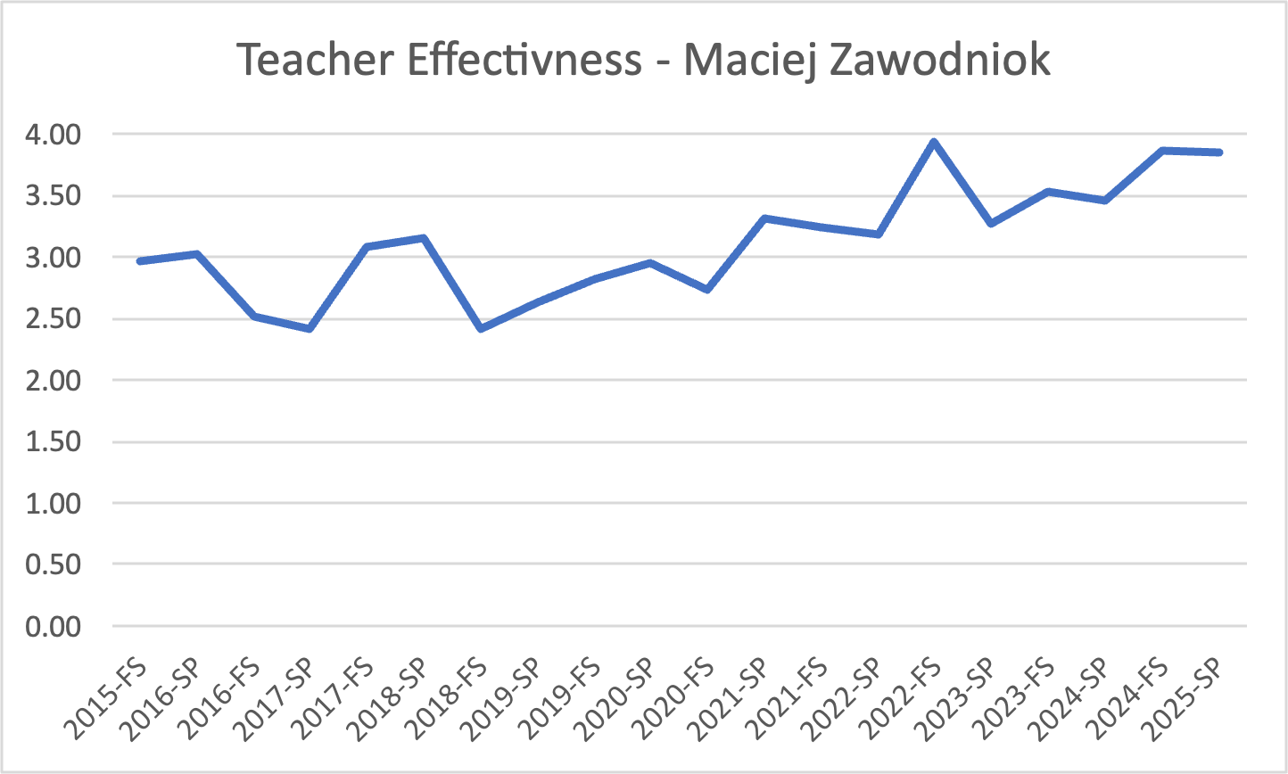  Figure 1. Overall teacher effectiveness (CET Question) - weighted average for each semester taught (weighted by number of responses) | 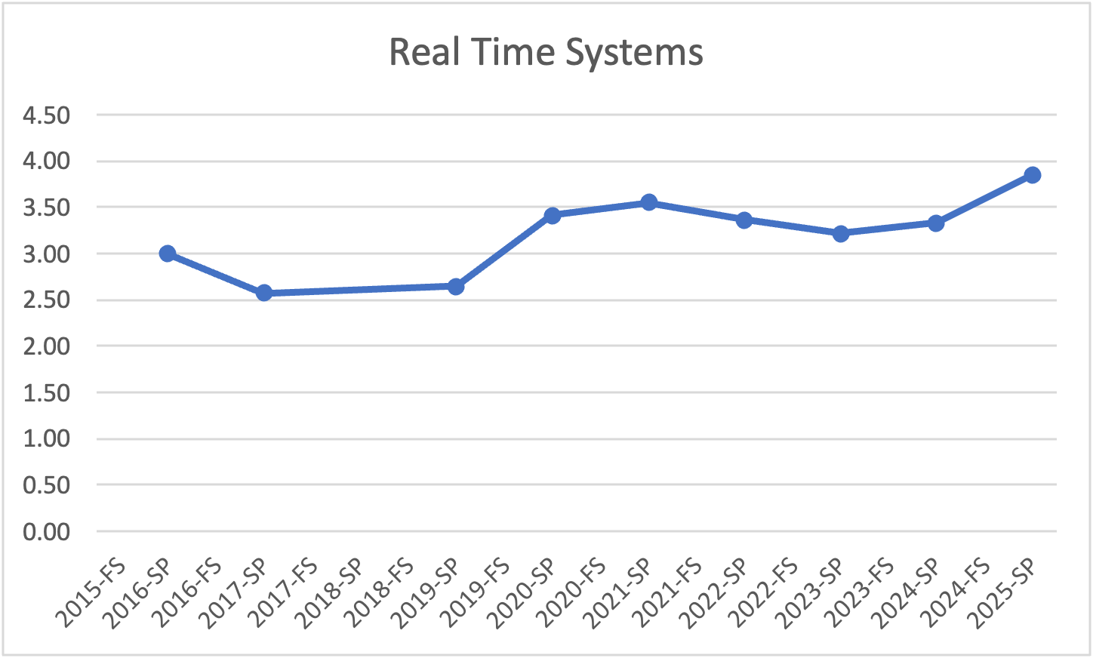  Figure 2. Teacher effectiveness (CET Question) for CpE5170/CS 5205 Real Time Systems course (same instructor)

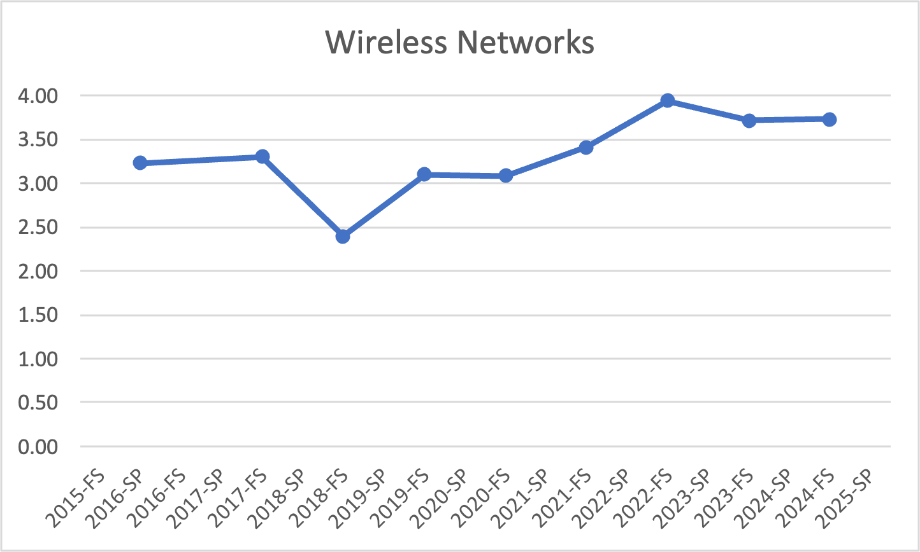  Figure 3. Teacher effectiveness (CET Question) - CpE/EE 5430/5420 Wireless Networks course (same instructor) | 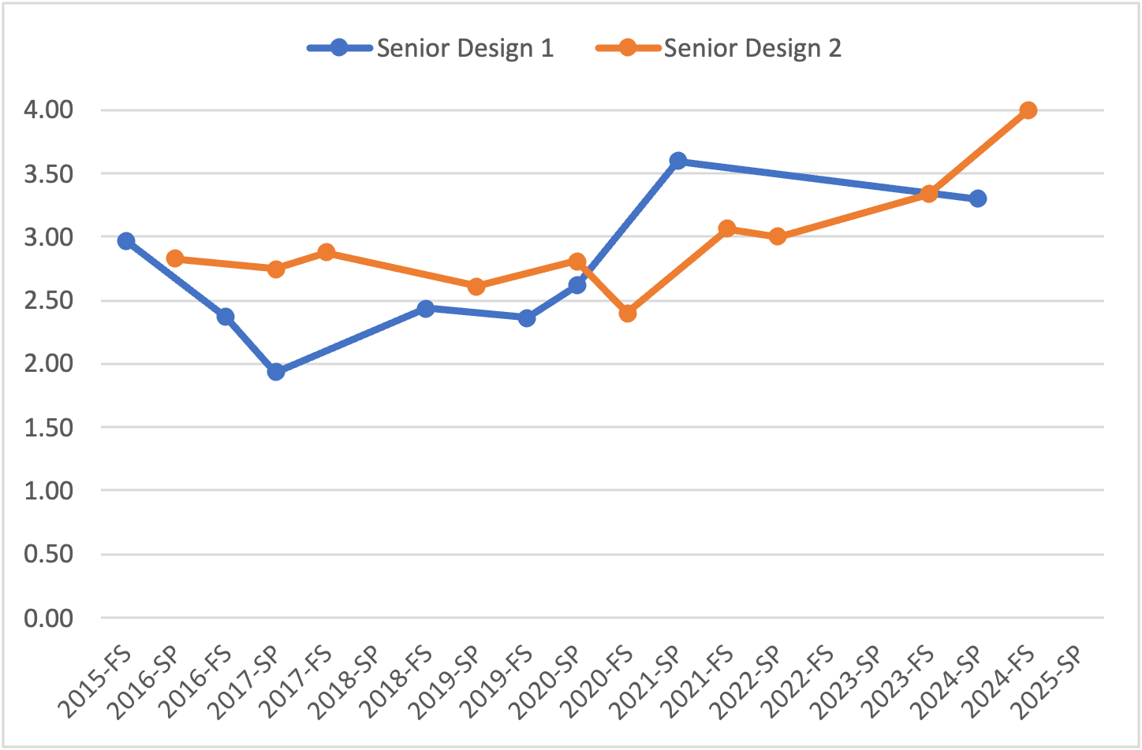  Figure 4. Teacher effectiveness (CET Question) for CpE/EE 4096 Senior Design 1 and CpE/EE 4096 Senior Design 2 courses (same instructor)

